1. Pearson’s corelation coefficient (r) -1(negative) to 1(positive) if 0 then no corelation
2. Spearman conf coeffi
3. Kendall

Remove indep attri that is redudied remove it

High corelated then remove

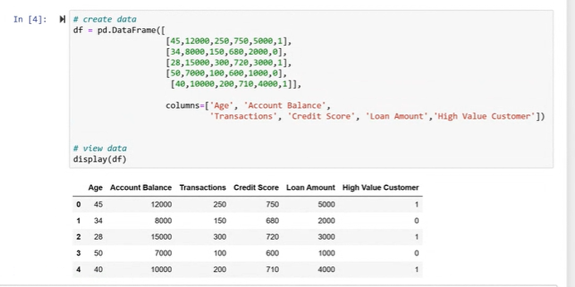

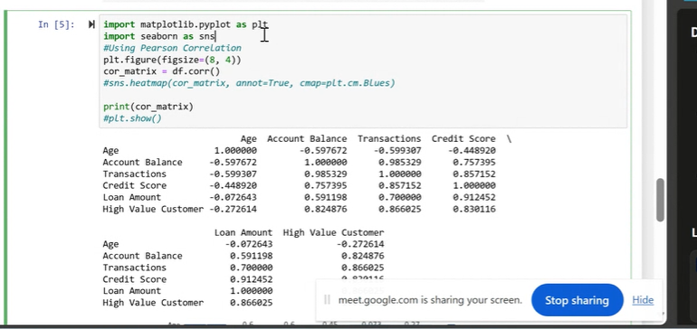

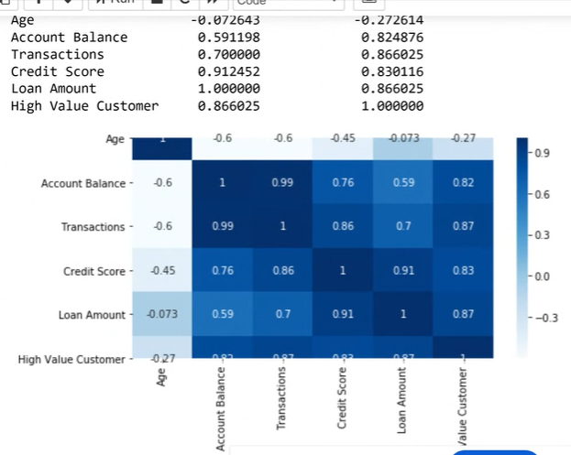

Dark colour- high corelated

